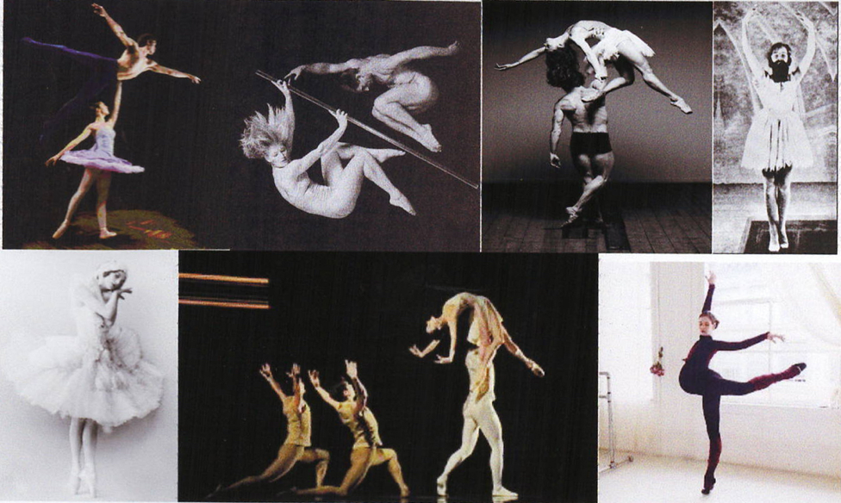

2019 Block 7-- English 111: Professor Leslie Kathleen Hankins

Virginia Woolf, Early Avant-garde Cinema, Male Privilege, & Gender Transformation:

*Jacob’s Room* to *Judith’s Room*:

The decade of the 1920s was all about experiments: in fiction, cinema, and gender—and also about male privilege, feminist challenges to said privilege, and gender experiments. Avant-garde film of the era played with dreamscapes and gender play, and introduced the Silent Hero of silent film, personified by Ivor Novello. Virginia Woolf, an iconic writer of the early 20th century, wrote her cinematic experimental novel, *Jacob’s Room* in 1922, exposing male privilege; later, her witty, brilliant essay, *A Room of One’s Own*, 1929, argues for a space for women writers. Fascinating as these two texts are to read together, we add to the mix the gender transformative 2017 *Judith’s Room*, a posthumous collaboration with Woolf by Hankins’ Making Waves Press. We will screen avant-garde and silent film. Students will write analytical papers, research about Woolf, gender theory and book design, compile annotated bibliographies, and work to develop solid writing skills.

Professor L. K. Hankins, 205 South Hall, [lhankins@cornellcollege.edu](mailto:lhankins@cornellcollege.edu)

Jennifer Ferrell, Writing Associate, Writing Studio, Cole Library, jhaigh@cornellcollege.edu

Jennifer Rouse, Consulting Librarian for the Arts & Humanities, 307 Cole Library, X4466,

[jrouse@cornellcollege.edu](mailto:jrouse@cornellcollege.edu)

Class Hours: Daily 1-3 with occasional morning classes & variations for conferences & workshops. Check dates/times daily.

Additional: Conferences as scheduled, Workshops as scheduled, Library presentations and Writing Studio appointments and presentations, as scheduled.

Office Hours: After class generally, Thursday, 3-3:30 and by appointment.

In this W course we will write daily: 24/7. English 111 is a very demanding course, with a lot of critical reading, writing, and thinking. Be Prepared for hard work—and also for improvement in your writing.

REQUIRED! Check your email twice a day for course information and Moodle alerts!

The course is structured to strengthen critical and creative thinking in 4 major areas:

Close Reading (careful attention to literary texts),

Close Viewing (careful attention to visual and film texts),

Close Study (thorough focused research in specific areas of study), and

Close Revision (thorough, comprehensive revision of writing, to incorporate research, to restructure, and to redraft)

**How to reach me: I enjoy working with you and encourage you to confer with me. The best way to reach me is by email: lhankins@cornellcollege.edu. My office (205 South Hall)**

Be prepared for necessary adjustments to the syllabus!!! Because such an interactive course needs to be revised almost daily, be prepared for changes in the syllabus. Assume class meets 1-3, and, when films and conferences require, 10-3.

CLASS EXPECTATIONS: Please know this information: See me immediately if you have any problems keeping up with the course. It is more difficult to repair serious gaps as the block goes on. You must be present in class daily and for all screenings, presentations, conferences and workshops in order to pass the course. All work must be handed in on time. Your classroom presence contributes to your grade; for workshops and discussions, your absence cannot be made up to your peers. You should not have unexcused absences, but be aware that if you do, you may fail the course with more than 2. Late papers may not be accepted, and if accepted may be penalized by at least a letter grade. You will be expected to write and write and rewrite and revise many times. Writing is like any form of exercise; the more you do it, the more you can do. Draft and redraft and redraft and redraft again. Put time and effort into your writing. Be sure to allow plenty of time for the research project; library research is time consuming and full of dead ends. Be prepared. I am eager to help you find topics that will be intriguing for you, and welcome conferences. To use the time most effectively, I expect you to be prepared for conferences, to have read the material and to have thought about the projects. You may not have all the answers, but I expect you to have taken some time to formulate a few questions.

Always cite sources and include a Works Cited if you used any sources—and that includes web finds and other students’ papers. Learn what correct MLA form is and use it regularly. Plagiarism is a TERRIBLY SERIOUS OFFENSE and may result in failing the course. Read pages about Plagiarism in the Little, Brown Essential Handbook for Writers. Using a paper you have handed in for another course, or which someone else has handed in for a course counts as plagiarism. You are in this class to work on your writing; using someone else’s writing will not help you. Plus, plagiarism = failure.

Use the Writing Studio regularly! Make appointments to meet with the Writing Associate, Jennifer Ferrell, often. You may be required to make regular appointments with the Writing Associate in addition to the usual appointments.

Tap the resources of our Consulting Librarians! Jen Rouse is the expert on tap for our course. Her expertise is invaluable. Of course, no matter how rushed you are, be considerate of her time and make appointments to allow time for calm work.

Disabilities and Accommodation. We would like all students to succeed at the college. If you have a disability that requires special accommodation, please visit the Cornell College registrar and the website about Disabilities Services; please alert the professor and consult the website if you think you require accommodation because of a disability. The student must have appropriate documentation on file at the Registrar's Office in order to be eligible for accommodation, and must request accommodation within the first three days of each term in order to be eligible for accommodation.

Required Texts: Being a Writer by Peter Elbow and Pat Belanoff. Boston: McGraw Hill 2003. An extremely valuable and very readable guide to the joys and struggles of writing

*Jacob’s Room* by Virginia Woolf, Norton Critical Edition

*A Room of One’s Own* by Virginia Woolf, Harcourt Annotated edition

*Composing Gender*, ed. Rachael Groner & John F. O’Hara.

*Judith’s Room*, a posthumous collaboration with Virginia Woolf, transformed and illustrated by Leslie Kathleen Hankins, Making Waves Press, 2017. (copies on loan to students)

Recommended Texts to enhance writing and grammar:

*SIGNS: A Grammar Handbook.* Any edition.

Recommended: Starkey, David. *Academic Writing Now: A Brief Guide for Busy Students*. Latest edition with 2016 MLA. Broadview Press.

Creating an intellectual community vs focus on GRADES: Bring your intelligent, thoughtful, articulate self to class each day, and to all your work. Rather than asking what you have to do, aim for the absolute best you can bring to the course. Grades: At Cornell College, we want you to do well and to work to your highest ability. We would like to see all students earn the best grades they are capable of earning. Remember, however, that professors don’t “give’ you grades; you earn them. College grades sometimes come as jolt after high school and inflated grades, because in college courses the bar is higher; you are expected to earn all grades through diligent, thorough, thoughtful and committed hard work. You don’t earn a grade by simply showing up. Consider a sports/arts analogy. Do we think a basketball player has done his or her job by just showing up for the game? Do we think entertainers earn an Academy Award by doing the minimum, learning all the lines and working hard? Or do we expect them to do all that and more, to do a superlative job? Let’s apply similar standards for academic work.

GRADE STANDARDS and Guidelines It is important to acknowledge that students earn their grades in college. They are not something the professor “gives” you. You may earn an A or an F or something in between; it depends upon your achievements, which often reflect your effort, though you are not graded for effort alone. You are expected to put solid intense effort into every course on the block plan, and to hand in all work at an acceptable level. You may not pass the course if you are missing ANY assignments. You may fail the course with 2 or more absences.

If you do poor work, miss class and do not contribute to the class, you may earn an F.

If you show up regularly and do all the work but not all that well you may earn a D.

If you do all the work and do it adequately, you may earn a C. You cannot pass without doing all the work at a passing level, and you are expected to challenge yourself.

To earn a B, show up eagerly, do all the work very well, set high standards for yourself and meet them, contribute to the class in meaningful ways, support your peers and the professor in building an academic intellectual community, and write, research and revise very well.

To earn an A, do all of this superbly, going well beyond the class expectations.

Writing and Thinking Process & Projects for the Course: English 111

All writings (and drafts/notes/lists/clusters/freewriting) should be kept in an ongoing portfolio to be collected at the end of the course; individual papers will be collected throughout the course. Keep the version with the professor’s comments in your portfolio. If you keep up with a writing journal, that should be included too. Some materials will be graded individually, though the portfolio will be graded as a whole) More detailed guidelines will be given in class and in separate handouts throughout the course. Stay alert!

Remember! You include a Cover Letter for All Papers

What is a cover letter?

After you complete each paper or project, review the assignment and compose a cover letter to me about the paper. In that letter, you consider the paper-writing process and evaluate your paper as a product. This thoughtful exercise in self-evaluation and reflection about your writing may help you to gain perspective on your writing as a whole. Focus on whatever is most important in your experience of each paper process.

1. In Class Essay on selected Gender Readings from *Composing Gender*. (with cover letter) 20%
2. A close reading of a short passage of *A Room of One’s Own*. The professor will provide useful passages and you select one. 3 pages + thoughtful cover letter. You will hand in hard copies of all materials you use to generate the paper in a manila folder, and upload the paper itself to Moodle. 20%
3. Research Proposal (Prospectus) project, including
   1. Works Cited for 2 articles/books/chapters
   2. a one page summary of one article from (a)
   3. Research log demonstrating that you worked with many of the search options: library books, on line resources, articles etc. (Jen Rouse has the log forms)
   4. A one page proposal presenting a topic for a research project you would like to do if you were able to, based on the research you have done. Alas, you do not have time to complete the research and writing in this course, but this project demonstrates that you have done the promising groundwork to launch such a project and of course, the thoughtful cover letter about the project. You will present the prospectus to class in a day when we share our proposals.
   5. Cover letter! 20%
   6. Revision of paper 2, using Elbow’s in depth suggestions for revision.

This is a thorough, major re-thinking of the paper that develops it through several new revised drafts, using free-writing, outlining and other skills to develop a solid revision. 20%

1. Take home final essay. 20%

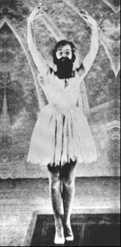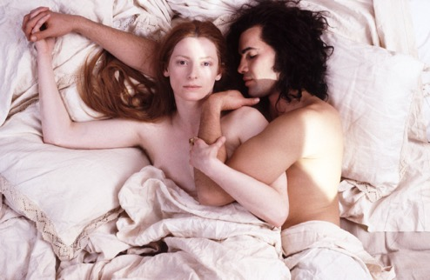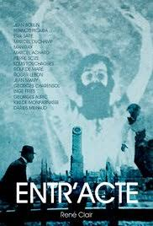

SCHEDULE DAY BY DAY

WEEK ONE: INVESTIGATING GENDER

Monday March 18: Afternoon 1-3. Screen *Entr’acte* by Rene Clair.

Introduction. In class writing. Gender/dance pictures.

Assign for tomorrow: Elbow readings: The Writing Skills Questionnaire (you can scan it, print it, and then fill it in to hand in). “Discovering Yourself as a Writer” pp. 3-13 and 19-24. (Pay attention to Elbow & Belanoff on Cover Letters). Freewriting p. 5. Read about the activities pp. 8-11 but do not do them. After you do the Elbow readings and projects, write and type up a 1-2 page letter to the professor & your peers introducing yourself as a writer, and include that in a folder with your Elbow materials. Who are you as a writer? Do you love writing? Fear it? Hate it? Why? What formative experiences have you had as a writer? What positive or negative feedback have you had in the past? What would you like to learn to do as a writer?

Assign for tomorrow: *Composing Gender* readings:

Section I Introduction, 14-18.

Lorder, ““Night to His Day”: The Social Construction of Gender.” 19-33.

Devor, “Becoming Members of Society.” 35-43.

Take good notes on the readings!

Tuesday March 19: 10-11 Share letters to professor. Discuss articles.

Assign: Renzetti/Curran from Women, Men and Society

Kane, “No Way My Boys are Going to Be Like That”

Wednesday March 20: 1-3 Screen and discuss Sally Potter’s *Thriller*.

Assign: Orbach “Losing Bodies”

Dines “Visible or Invisible”

Pascoe “Dude, You’re a Fag.”

Collins, “Hegemonic Masculinity and Black Gender Ideology.” 222-238.

Thursday March 21: 1-3 Screen and discuss *Daughters of the Dust* by Julie Dash.

Friday March 22: 1-3: Discussion and preparation for in class essay test Monday. “Sharing & Responding” in Elbow & Belanoff, pp. 351-366

“Drafting and Revising” 109-169. “Reflecting on Your Writing” 329-350.

Elbow “Writing Under Pressure” A-1 through A-7 (especially good for writing in class essay)

WEEKEND March 23-4

SATURDAY & SUNDAY:

WEEK TWO:

Monday March 25: Afternoon 1-3: In class essay in bluebooks.

Assign: type up bluebook essay double spaced. Submit via Moodle.

Read *A Room of One’s Own* Chapters 1-3. Do not read Introduction yet.

Tuesday March 26: 10-11 Discuss Chapters and close reading guidelines.

1-3 workshop passages with Jennifer Ferrell on close reading.

Assign: Complete AROO

Read essay on Moodle: “Essay as Novel”

Wednesday March 27: 1-3 Class on AROO

Thursday March 28: 10-11 workshop with Jennifer Ferrell on how to read and summarize a scholarly article and how to cite MLA format.

1-3 class on preparing draft and on Introduction and conclusion variation. Bring your penultimate drafts to work on. Paper due at midnight.

Friday March 29: 10-11 Jen Rouse

You will learn from the presentation by Jen Rouse how to search for good scholarly articles on AROO that will help revise and develop your AROO papers.

1-3: Class on Revision and Research.

Read Elbow chapters on Revision and Research. Revision, Part II. Drafting and Revision. Special attention to pp.124-6.

Elbow chapter “Research” read selectively in this chapter, focusing on what is relevant for this class. 271-327

WEEKEND March 30-March 31

WEEK THREE: GENDER TROUBLE & TRANSFORMATIONS

Monday April 1: Individual Conferences about papers, Research and Revision.

Jen Rouse times available. Make appt.

Assign: work on Research Projects

Tuesday April 2: 10-11. Workshop on Research Projects.

Assign: Complete Research project. Due 6 p.m.

Prepare to share.

Work on paper revisions.

Wednesday April 3: Share Research projects. Workshop revisions.

Read: “A Society” “How Should One Read a Book?” “The Cinema”

“Speech for Professions for Women”

Thursday April 4. 1-3 Screen “Suffragettes in Early Cinema”

Discuss strategies for reading VW.

Assign *Jacob’s Room* chapters 1-3 and *Judith’s Room*, chapters 1-3.

Assign: Bem “On Judith Butler.”

Friday April 5: 1-3 Discuss JR/JR Chapters 1-3. Pay special attention to the way gender performance & privilege in *Jacob’s Room* and *Judith’s Room* affect you.

Assign: Complete JR/JR. Read Doan, “The Tyranny of Gendered Spaces.”

Schwartz, “The Social Construction of Heterosexuality”

Assign: Complete JR/JR

WEEKEND April 6-7

SATURDAY & SUNDAY.

WEEK 4: THE GRAND FINALE

Monday April 8: 1-3 Screen and discuss *Orlando*

Tuesday April 9: workday for final take home essay.

Wednesday April 10: Share take home essays and celebrate.